Alg 2 Night School Name: ____________________________

____________ ____________
WS Assessment

Target 2:
TWO VARIABLE STATS
LINE OF BEST FIT

I can :
- Determine line of best fit by hand and graphing calculator
- Interpret slope, intercept and discuss the correlation (positive, negative, none) vs. causation
Standard: A4. Statistics0
● A4a. I can determine the line of best fit.
● A4b. I can represent one variable data on a scaled number line.

Intro to Two Variable Stats
Correlation: is a statistical measure that indicates the extent to which two or more variables fluctuate together. A positive correlation indicates the extent to which those variables increase or decrease in parallel; a negative correlation indicates the extent to which one variable increases as the other decreases.
A perfect correlation r = ± 1 occurs only when the data points all lie exactly on a straight line. A correlation greater than 0.8 is generally described as strong, whereas a correlation less than 0.5 is generally described as weak.
Interpreting a Scatter Plot
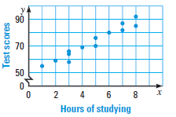a. Independent variable _______________
Dependent variable _______________
b. ______________________ depends on
________________________.
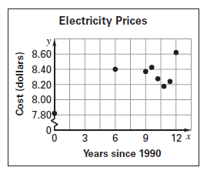
c. Correlation_____________________

a. Independent variable _______________
Dependent variable _______________
b. ______________________ depends on
________________________.
c. Correlation_____________________
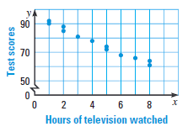
a. Independent variable _______________
Dependent variable _______________
b. ______________________ depends on
________________________.
c. Correlation_____________________

a. Independent variable _______________
Dependent variable _______________
b. ______________________ depends on
________________________.
c. Correlation_____________________

Review: Write the equation of the lines that pass thru 2 points
(80, 240) and (110, 180) (1, 151) and (15, 400)

Finding Trend Lines (Line of Best fit)
Roller Coasters: The table shows the largest vertical drops of nine roller coasters in the United States and the number of years after1988 that they were opened.
Years since 1998 | 1 | 3 | 5 | 8 | 12 | 12 | 12 | 13 | 15
Vertical Drop (ft) | 151 | 155 | 225 | 230 | 306 | 300 | 255 | 255 | 400

What is the independent variable?___________ What is the dependent variable? ________________
Make a scatter plot of the data (x-scale = 1; y-scale = 20)
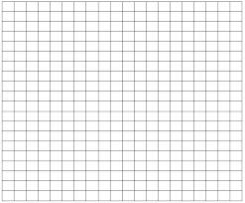
What is the correlation?

Draw the trend line and find its equation

Predict the vertical drop in a roller coaster built 30 years after 1988 (x = 30 → y = ?)

Population The past and predicted populations for Smallville over a 25-year period are show below
Year | 1985 | 1990 | 1995 | 2000 | 2005 | 2010
Population | 248 | 241 | 219 | 216 | 199 | 189

What is the independent variable?___________ What is the dependent variable? ________________
Make a scatter plot of the data (x-scale = 1; y-scale = 10)
What is the correlation?

Draw the trend line and find its equation

Predict the population of Smallville in 2020

Trend Line Systems
Are students who are exposed to more violent video games more likely to get in physical fights? Data is presented below
Exposure to violent video games on a scale of 1 to 4 (1 least exposure and 4 most) | Percentage of students who have been in a physical fight in the last year.
1 | 28
2 | 37
3 | 58
4 | 63

Plot the data and find the equation of the trend line

Now we find the equation of the trend line using graphing calculator (Show me for stamp)
Set up for 3 decimals number (MODE – FLOAT – 3)
Enter the data in L1 and L2 (STATT-EDIT) Set up Scatter Plot (STATPLOT – 1 )
Set up Windows (WINDOW – 9) Find Equation (STAT – CALC – 4)
Send Equation to Graph (VARS -Y VARS- FUNCTION-Y1-Enter)
Check the correlation (Home screen)
Show me the graph on calculator with trend line __________________________ Stamp
Write equation here (using 3 decimals) Y1 = _____________________________
Correlation r = _________________ strong / weak / on none at all

2. An Oregon Ducks receiver catches An OSU Beaver defensive player at
the ball at 50 yard line, run to end zone the 75 yard line is chasing the Duck

One by one, enter the data of each player in L1, L2 and find the equation line of them
Duck Beaver
Y = Y =
Determine algebraically where the tackle will occur.

Assessment Target 2 Name:_______________________ Date: __________
I can… do line of best fit to make predictions and analyze the reasonableness of the solutions
Data and Ipods

Identify and explain independent and dependent variables.

Dependent:
why?

Independent:
why?

Now you do the followings (Using 3 decimals number)
- Create a x-y graph to plot the data (scale appropriately), sketch the trend line.
- Find the equation of the trend line using algebraical.
- Enter data into calculator and find the line of best fit, record down the correlation r
- Predict how many songs a 64 gig iPod would carry. Show work
- Predict how many gigs you would need to carry 100,000 songs. Show work
- Show me the scatter plot with trend line for stamp __________________

